

**Tribhuvan University**

**Faculty of Humanities and Social Sciences**

**The Times Int’l College**

## SUPERVISOR’S RECOMMENDATION

I hereby recommend that this project prepared under my supervision by **Sujan Katuwal and Koshish Neupane** entitled **“EXPENSE MANAGEMENT SYSTEM”** in partial fulfillment of the requirements for the degree of Bachelor of Computer Application is recommended for the final evaluation.

**…………………**

**SIGNATURE**

**Jiwan Khadka**

**Supervisor**



**Tribhuvan University**

**Faculty of Humanities and Social Sciences**

**The Times Int’l College**

**LETTER OF APPROVAL**

This is to certify that this project prepared by **Sujan Katuwal** and **Koshish Neupane** entitled “**EXPENSE MANAGEMENT SYSTEM”** in partial fulfillment of the requirements for the degree of Bachelor in Computer Science has been evaluated. In our opinion, it is satisfactory in the scope and quality as a project for the required degree.

|  |  |
| --- | --- |
| **……………………**  **Jiwan Khadka**  **Supervisor**  **The Times Int’l College, Dillibazar** | **……………………..**  **Santosh Gautam**  **Coordinator**  **The Times Int’l College, Dillibazar** |
| **……………………**  **Internal Examiner** | **………………...…..**  **External Examiner** |

## ACKNOWLEDGEMENT

We are very grateful to the department of computer application, The Times College for providing us an opportunity to work on a major project as a part of our second year project. We are warmed to express our deep sense of appreciation and indebtedness to our learned supervisor **Mr. Jiwan Khadka,** for his encouragement, invaluable guidance, and even monitoring to spare time despite his busy schedule for project’s progress reviews.

Our special thanks go to our mates and everyone who directly and indirectly extended their hands in making this project success.

Sujan Katuwal

Koshish Neupane

## ABSTRACT

An expense is any cost incurred by an individual or organization to acquire goods, services, or fulfill obligations. It is essential for daily operations, achieving goals, or maintaining a certain standard of living. An Expense Management System is a software solution or tool designed to track, control, and streamline the process of managing expenses for individuals or organizations. It simplifies the handling of expense-related activities, from recording and reporting to approving and reimbursing, ensuring compliance with policies and reducing administrative overhead. It allows users to record expenses manually or through automated data capture, such as scanning receipts or importing credit card transactions for expenses recording. Real-Time Reporting provides insights into spending trends, budget utilization, and financial projections through dashboards and analytics. Expenses management offers mobile apps for expense submission, approval, and tracking on the go by mobile accessibility. Digital Receipt Management enables users to store and organize receipts digitally for easy retrieval and auditing. It reduces efficiency and cost control. Transparency in financial management, improves decision making by aiding in strategic planning. Simplifies the process for users to submit, review, and approve expenses, which even makes it user-friendly.

**Keywords:** Expense, Expense Account, Entities, Users, Admin.

## TABLE OF CONTENTS

SUPERVISOR’S RECOMMENDATION I

ACKNOWLEDGEMENT III

ABSTRACT IV

TABLE OF CONTENTS V

LIST OF FIGURES VII

LIST OF TABLES VIII

LIST OF ABBREVIATIONS IX

CHAPTER 1 1

INTRODUCTION 1

1.1 Introduction 1

1.2 Problem Statement 1

1.3 Objective 1

1.4 Scope and Limitations 1

1.5 Report Organization 2

CHAPTER 2 3

BACKGROUND STUDY AND LITERATURE REVIEW 3

2.1 Background Study 3

2.2 Literature Review 3

CHAPTER 3 5

SYSTEM ANALYSIS AND DESIGN 5

3.1 System Analysis 5

3.1.1 Requirement Analysis 6

3.1.2 Feasibility Analysis 9

3.1.3 Data Modelling(ER-Diagram) 10

3.1.4 Process Modelling (DFD) 11

3.1.5 Level 1 DFD 12

3.2 System Design 12

3.2.1 High Level Design 13

3.2.2 Architectural Design 14

3.2.3 Database Schema 15

3.2.4 Interface Design (UI Interface/ Interface Structure Diagrams) 16

3.2.5 Physical DFD 19

CHAPTER 4 20

IMPLEMENTATION AND TESTING 20

4.1 Implementation 20

4.2 Tools Used 20

4.3 Implementation Details of Modules 21

4.4 Testing 22

4.4.1Test Cases for Unit Testing 22

4.4.2 Test Case for System Testing 25

CHAPTER 5 26

CONCLUSION AND FUTURE RECOMMENDATION 26

5.1 Lesson Learnt / Outcome 26

5.2 Conclusion 26

5.3 Future Recommendation 26

APPENDICES 27

REFERENCES 32

## LIST OF FIGURES

Figure 3.1 Waterfall Methodology 5

Figure 3.2 Use Case Diagram of Expense Management System 7

Figure 3.2 ER diagram of Expense Management System 10

Figure 3.3 Context Diagram of Expense Management System 11

Figure 3.4 DFD Level One of Expense management System 12

Figure 3.5 High Level System flow chart of Expense Management System 13

Figure 3.6 Architectural Design of Expense Management System 14

Figure 3.7 Database Schema of EMS 15

Figure 3.8 Landing page Design of EMS 16

Figure 3.9 Registration Page Design of EMS 17

Figure 3.10 Login Page Design of EMS 17

Figure 3.11 User Expenses Dashboard design of EMS 18

Figure 3.12 Add Control Panel Page Design of EMS 18

Figure 3.13 Physical DFD of EMS 19

Figure 5.1 Home page 27

Figure 5.2 login page 27

Figure 5.3 Sign Up page 28

Figure 5.4 Expenses page 28

Figure 5.5 User profile page 29

Figure 5.6 Admin Dashboard page 29

Figure 5.7 Manage users page 30

Figure 5.8 Admin profile page 30

Figure 5.9 Users Charts Page 31

Figure 5.10 Users Settings Page 31

## LIST OF TABLES

Table 4.1 Test Cases for Registration Module 22

Table 4.2 Test Cases for User Login Module 23

Table 4.3 Test Cases for Add Expenses Module 24

Table 4.4 Test Cases for Add Income Module 25

## LIST OF ABBREVIATIONS

**CSS Cascading Style Sheet**

**DFD Data Flow Diagram**

**ER Entity Relationship**

**EMS Expense Management System**

**HTML Hypertext Markup Language**

**HLD High Level Design**

**JS JavaScript**

**LLD Low level Design**

**PHP Hypertext preprocessor**

**SQL Structured Query Language**

**UI User Interface**

**XAMPP Cross-Platform, Apache, MySQL, PHP, Per**

## CHAPTER 1

## INTRODUCTION

### 1.1 Introduction

An expense is a cost incurred by a business, organization, or individual in the process of producing goods or services, maintaining operations, or achieving a specific financial goal. In both personal finance and business accounting, understanding and managing expenses is crucial for maintaining financial health and ensuring profitability.

The uses of internet have been widely used in various sectors, which motivate us to use the internet and its technology in the field of expenses sector. Hence, to overcome such problem such problem that leads to inaccurate and error in details of data we developed software for providing the service of managing the data.

The system we have built made by using free technology available on the internet. In addition, these technologies include

### 1.2 Problem Statement

* Improper handling of expenses can lead to financial strain, or even business failure.
* So, it can be challenging for both individuals and business.
* Lack of clear budgeting, It is difficult to track and control expenses effectively. Without accurate records, it affects poor tracking and record keeping.

### 1.3 Objective

The design of expenses management system performed following activities and function:

* To ensure funds allocated effectively for maximum benefit.
* To provide accurate financial data that supports better strategic decisions.
* To prevent overspending and waste.

### 1.4 Scope and Limitations

The project designed in order to provide automation to the expenses management system. The expenses done manually with a lot of error. This project emphasizes on providing facilities that are easily accessible to the users.

**1.4.1 Scopes**

The system which have been built is able to perform various tasks such as controlling,

monitoring and optimizing expenses and it scopes are listed below:

* Creating and updating budgets periodically.
* Reviewing spending trends to identify irregularities or overspending.
* Identifying and analysing areas of overspending or inefficiency.

**1.4.2 Limitations**

The project allows tracking and controlling of costs. Moreover, there are some limitation which are listed below:

* It can be extremely time-consuming in manual tracking.
* Data entry mistakes occurs in expense reports entered by manual, which increases the likelihood of errors.

### 1.5 Report Organization

The report document contains five chapters including:

* **Chapter 1: “Introduction”** – This chapter describes the introduction of the built system. It also contains problem statement, objective, scopes and limitations of Expense Management System.
* **Chapter 2: “Background Study and Literature Review”** – This chapter describes the background of the study and reviews the existing literature relevant to the project.
* **Chapter 3: “System Analysis and Design”** – This chapter presents the System Analysis and Design including Requirement Analysis and Feasibility Analysis.
* **Chapter 4: “Implementation and Testing”** – This chapter presents the methods and tools used to implement the project, along with testing processes.
* **Chapter 5: “Conclusion and Future Recommendations”** – The concluding chapter summarizes the successful completion of the project and discusses future developments and plans for its expansion.

## CHAPTER 2

## BACKGROUND STUDY AND LITERATURE REVIEW

### 2.1 Background Study

The current expense management system is slow because it relies on manual work. Humans process expenses at a much slower pace compared to computers. As the number of clients’ increases, the volume of expenses also grows, making the system even more complex. All expenses must recorded manually for future reference, which can be time-consuming and inefficient.

In today’s digital world, internet usage is widespread, and people prefer convenient solutions. To address this, we developed an online module that allows users to create and access their accounts through the internet. This system efficiently records and manages expense data. With an automated application, tasks become more accurate, errors are minimize, and workload reduced.

Expense Management Systems (EMS) have evolved from slow, manual methods to fast, automated solutions. Managing expenses efficiently is important to reduce errors, prevent fraud, and simplify financial processes.

### 2.2 Literature Review

Different article, documentation, and project have been referred related to expense

Management system etc. in the preparation of this report. A sort summary of these report

sources are mentioned below:

Several researchers and organizations have developed EMS solutions to improve financial tracking and efficiency.

According to Smith et al. [1], traditional manual expense management methods often lead to inefficiencies, errors, and fraud. These methods typically involve physical receipts, manual data entry, and paper-based approvals, making the process time-consuming and prone to inaccuracies. Furthermore, manual processes lack real-time tracking, leading to delays in reimbursement and financial reporting.

According to Kumar and Sharma [2], organizations using such automated systems have reported a reduction in processing time by up to 40%. These systems automate expense tracking, approval workflows, and reimbursement processes, thereby enhancing accuracy and efficiency. Features such as AI-driven fraud detection, real-time policy enforcement, and mobile accessibility further improve the system’s effectiveness.

Studies by Williams and Thompson [3] show that businesses implementing EMS achieve higher operational efficiency and cost savings. These systems not only reduce administrative burdens but also enhance financial transparency and policy adherence.

Several EMS platforms have established themselves in the market:

* **Expensify**: A user-friendly EMS offering AI-driven receipt scanning and policy compliance automation [4].
* **Zoho Expense**: A cloud-based platform that simplifies expense tracking and reimbursement workflows [5].
* **Emburse**: Provides solutions to control spend, manage expenses, and handle corporate travel [6].
* **BILL Spend & Expense**: Offers credit lines combined with free expense management software, providing real-time visibility and control over business finances [7].

## CHAPTER 3

## SYSTEM ANALYSIS AND DESIGN

### 3.1 System Analysis

Considering the fact that this projects involves design and implementation of a software system regardless that is web-based, it was necessary to mention and consider certain models used in software development and deployment, including the following generic software development models.

**The Waterfall Development model for software development**

This is the model through which the expense system was created. During the software development process, however, feedback loops were there. For the project, the model selected must favour two developers.

Software development should be interleaved, according to the waterfall approach. It necessitates software development follows the following stages:

* Analyses the problem is made and requirements to be meet are proposed.
* After the design is completed, the process of implementation and debugging starts.
* The program is tested and integration of the system made.

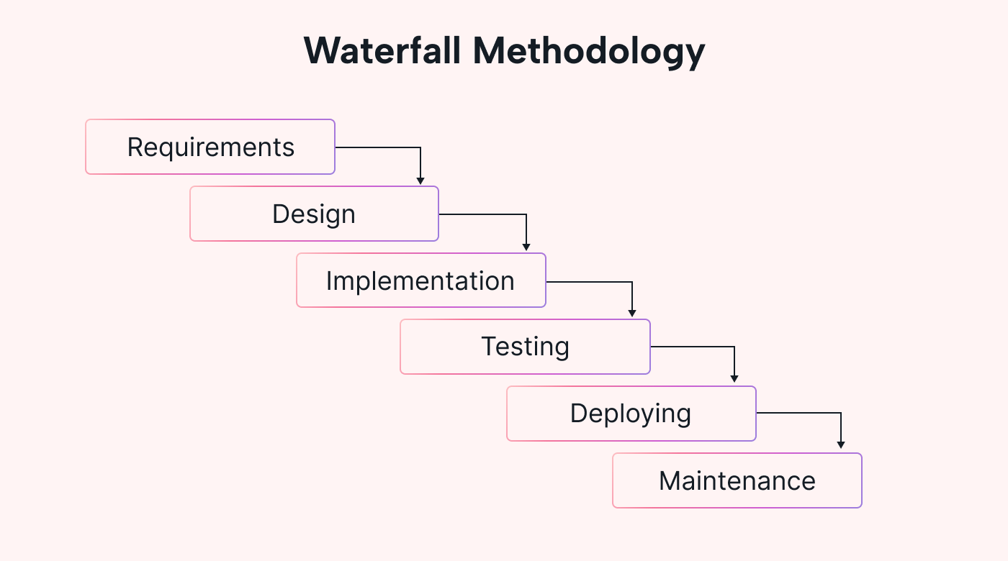

Figure 3.1 Waterfall Methodology

### 3.1.1 Requirement Analysis

Requirement analysis is a crucial step for determining the success of a system or software project. Requirements are generally split into two types:

* Functional requirements
* Non- functional requirements

1. **Functional Requirements**

This section provides the requirements overview of the system. Various modules implemented by the system are:

* **Admin Module**
* Admin can approve registration requests.
* Admin can manage users.
* **User Module**
* User can sign up and login the system.
* User can perform the add expenses.
* User can get expenses detail after performing each expenses.
* User can logout from the system after completion of expenses.
* **Login Module**
* Only registered user can login the dashboard.
* It helps to authenticate the users.
* Only valid email and password used to login the system.
* **Add Expenses module**
* After logging in the system user can perform the expenses.
* After every expenses user can see his expenses detail.
* It ensures user that expenses performed successfully.
* **Remove user or delete user module**

Users can perform this feature.

* User can delete or remove their account by self.
* Admin can also delete or remove their account by self.

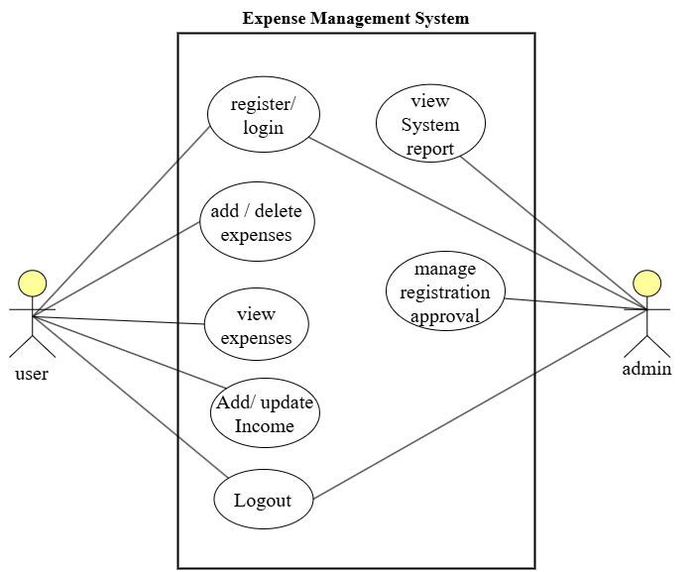

Figure 3.2 Use Case Diagram of Expense Management System

1. **Non-Functional Requirement**

Non-Functional requirements of the system identified as Efficiency Requirements, Reliability Requirements and Usability Requirements. The non-functional requirements included in the project are:

1. **Efficiency Requirement**

The efficiency of the software system refers to how well it handles capacity, throughout and response time. With the development of the expense management system, both users and administrators may easily access the expense and user were able to perform transaction.

1. **Reliability Requirement**

The degree to which the system regularly executes the stated functions without the failure referred to as reliability. User registration, login, transaction detail, and balance inquiry, all performed accurately by the system.

1. **Usability Requirement**

The system’s usability criteria states how simple it must be to use. The system designed in a user-friendly environment so that users easily and successfully complete various activities in the system.

### 3.1.2 Feasibility Analysis

1. **Technical Feasibility**

These include hardware, software and technologies. The suggested system is technically possible because it requires access to the use of a browser and the internet. The system’s user interface is also quite simple.

1. **Operational Feasibility**

Reliability, maintainability, usability, and supportability are among them. The suggested system is operationally practical since it is reliable for all type of users, regardless of whether or not they are computer literate. It is simple and straightforward to use.

1. **Economic Feasibility**

The project developed within the organization’s budgetary constraints. The project resource was freely available, and no additional obligations are required. The creation of the system does not necessitate the use of expensive hardware or software. The platform are open sources and the resources required for the project are open source.

1. **Schedule Feasibility**

Among various phases of the project, data collecting took longer time as data collected from various customers. After the data acquired, the next development phase completed in as little as a month.

### 3.1.3 Data Modelling(ER-Diagram)

This ER (Entity Relationship) Diagram represents the model of “Expenses management System” shows as all the visual instrument of database tables and the relation between Admins, Users, and list of expenses. It used structure data and to define the relationship between structured data groups of “Expense Management System” functionalities. Database system contains user and account entities, which contain a primary key as a unique identifier for each entity and other attribute to show the properties of these entities. ER diagram of expense management system:

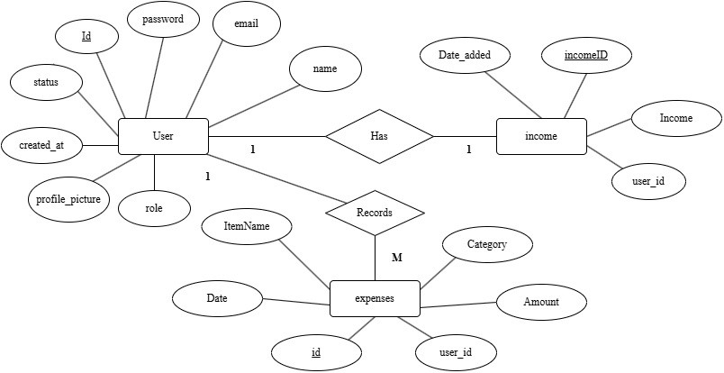

Figure 3.2 ER diagram of Expense Management System

### 3.1.4 Process Modelling (DFD)

Process modeling is a technique used to visually represent the flow of processes, data, and interactions within a system. It helps in understanding system behavior, optimizing workflows, and identifying inefficiencies. In an expense management system, process modeling includes a context diagram that provides a high-level overview of the system, showing external entities interacting with it. Data Flow Diagram (DFD) Level 1 breaks down the system into main processes, depicting data flow between users, databases, and subsystems. The physical DFD further details how the system is implemented, specifying hardware, software, and data storage components involved in managing expenses.

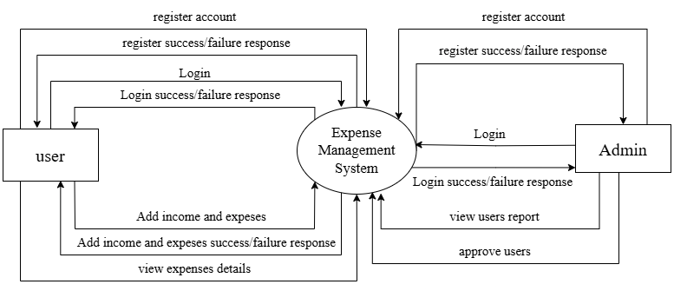

Figure 3.3 Context Diagram of Expense Management System

### 3.1.5 Level 1 DFD

DFD Level 1 for an Expense Management System expands on the context diagram by breaking down the main processes and their interactions with users and the admin. It details how data moves through the system, ensuring a clear understanding of its functionality. The key processes include **Login/Register, Expense Management, Income Management, and Manage Users**. The system records and categorizes expenses, updating the database accordingly. Admins oversee approvals.

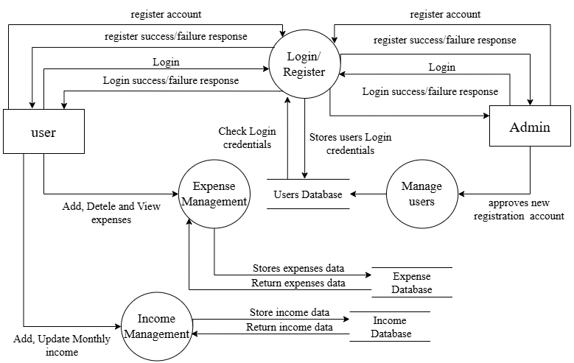

Figure 3.4 DFD Level One of Expense management System

### 3.2 System Design

System design for an Expense Management System outlines the architecture, components, and data flow required for efficient functionality. It includes both **high-level design (HLD)**, which defines system architecture, modules, and interactions, and **low-level design (LLD)**, which details database structures, algorithms, and user interfaces

### 3.2.1 High Level Design

High-Level Design (HLD) for the Expense Management System provides the system’s overall structure, major components, and interactions. This design serves as a foundation for detailed implementation, guiding the development process efficiently.

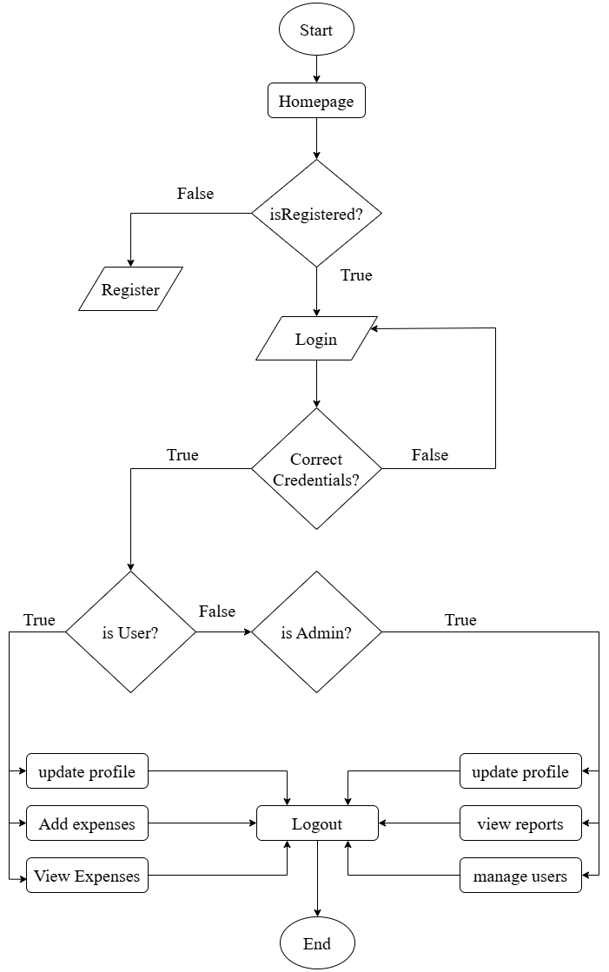

Figure 3.5 High Level System flow chart of Expense Management System

### 3.2.2 Architectural Design

The **Architectural Design** of the Expense Management System defines the system’s structure, components, and data flow to ensure efficiency, scalability, and security. It follows a **layered architecture**.

It follows a **three-tier architecture**, consisting of:

1. **Presentation Layer** – Built using **HTML, CSS, and JavaScript**, this layer provides the user interface for both users and admins to interact with the system.
2. **Business Logic Layer** – Developed in **PHP**, this layer handles core functionalities like expense processing, approval workflows, and validation.
3. **Data Layer** – Powered by **MySQL**, this tier manages data storage, handling expense records, user details, and reports securely.

This architecture ensures smooth communication between components, secure authentication, and optimal system performance.

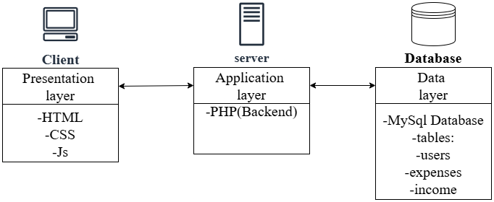

Figure 3.6 Architectural Design of Expense Management System

### 3.2.3 Database Schema

The **Database Schema** of the Expense Management System defines the structure of data storage, ensuring efficient organization and retrieval. It includes key tables such as **Users Expenses**, **and** **Income.** Relationships between these tables ensure seamless data flow, enabling users to submit expenses, admins to approve users, and the system to generate reports. The schema is designed for data integrity, security, and scalability.

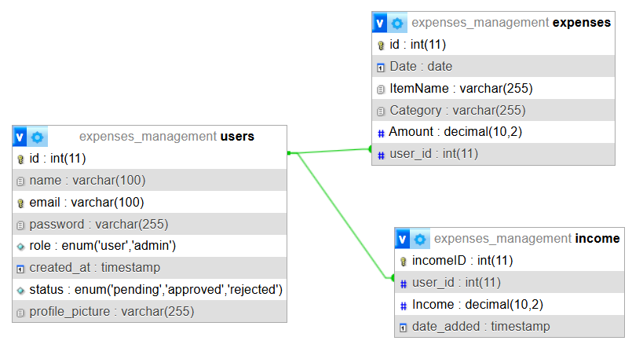

Figure 3.7 Database Schema of EMS

### 3.2.4 Interface Design (UI Interface/ Interface Structure Diagrams)

The **Interface Design** of the Expense Management System focuses on a user-friendly and intuitive experience. The primary interfaces include:

* **Landing Page** – Provides an overview of the system and its features.
* **Registration Page** – Allows new users to sign up with required details.
* **Login Page** – Secure authentication for users and admins.
* **User Expenses Dashboard** – Enables users to submit, track, and manage expenses.
* **Admin Control Panel** – Allows admins to review and approve users, manage users.

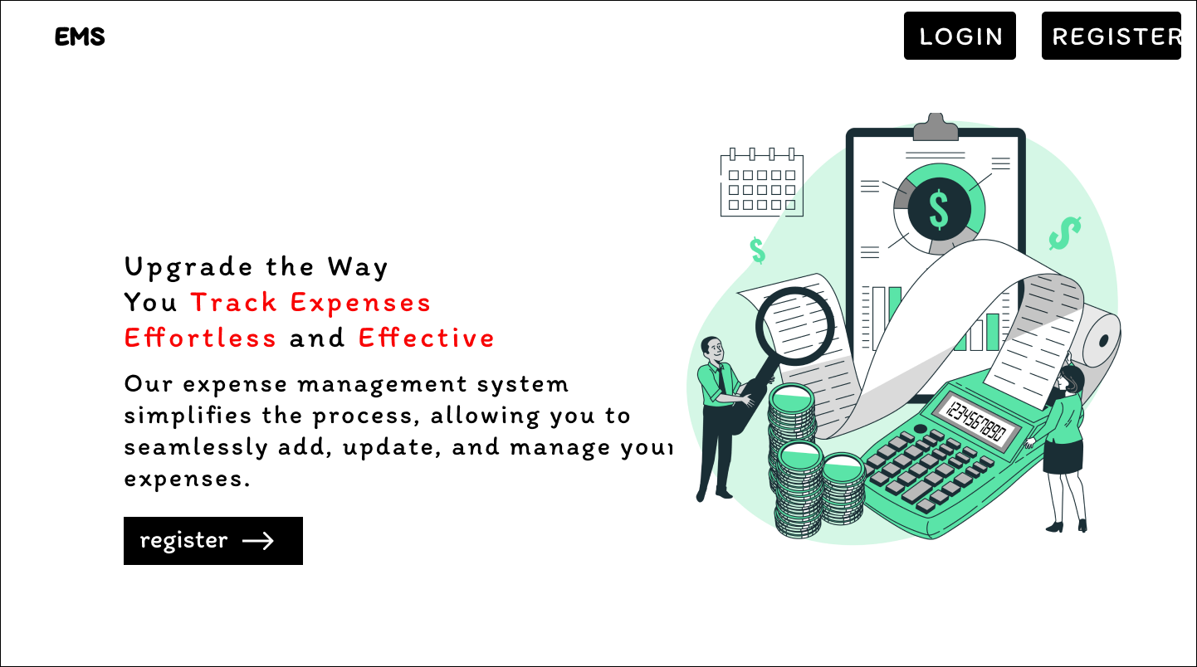

Figure 3.8 Landing page Design of EMS

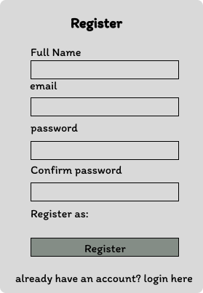

Figure 3.9 Registration Page Design of EMS

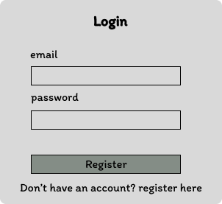

Figure 3.10 Login Page Design of EMS

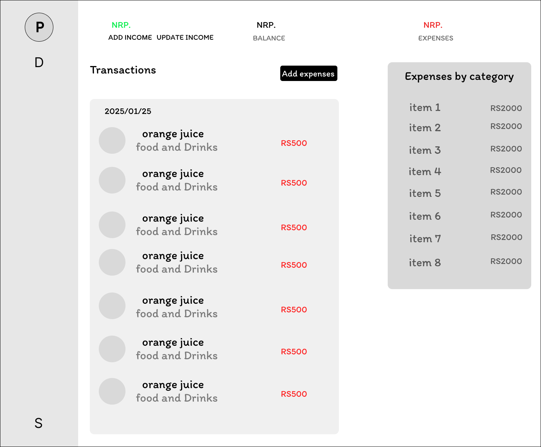

Figure 3.11 User Expenses Dashboard design of EMS

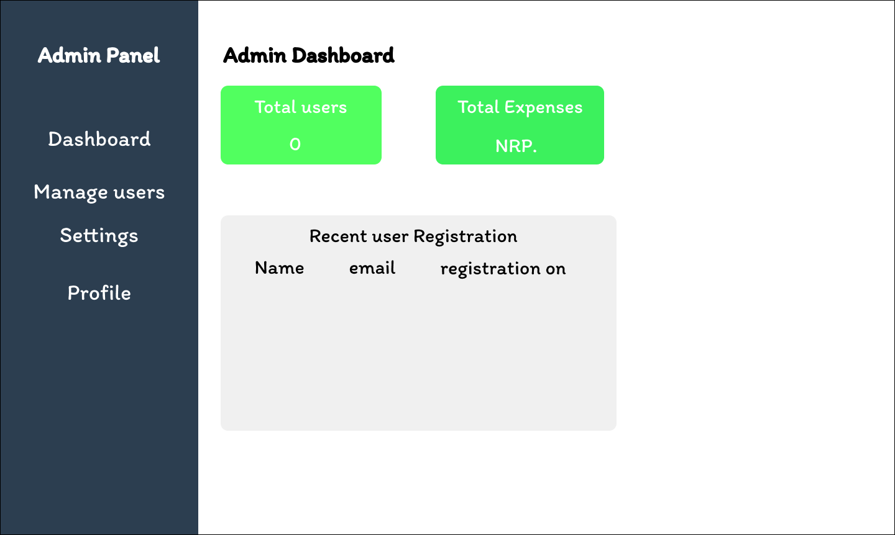

Figure 3.12 Add Control Panel Page Design of EMS

### 3.2.5 Physical DFD

The **Physical Data Flow Diagram (Physical DFD)** of the Expense Management System represents the actual implementation of the system. This diagram helps in understanding the system’s technical infrastructure and optimizing performance.

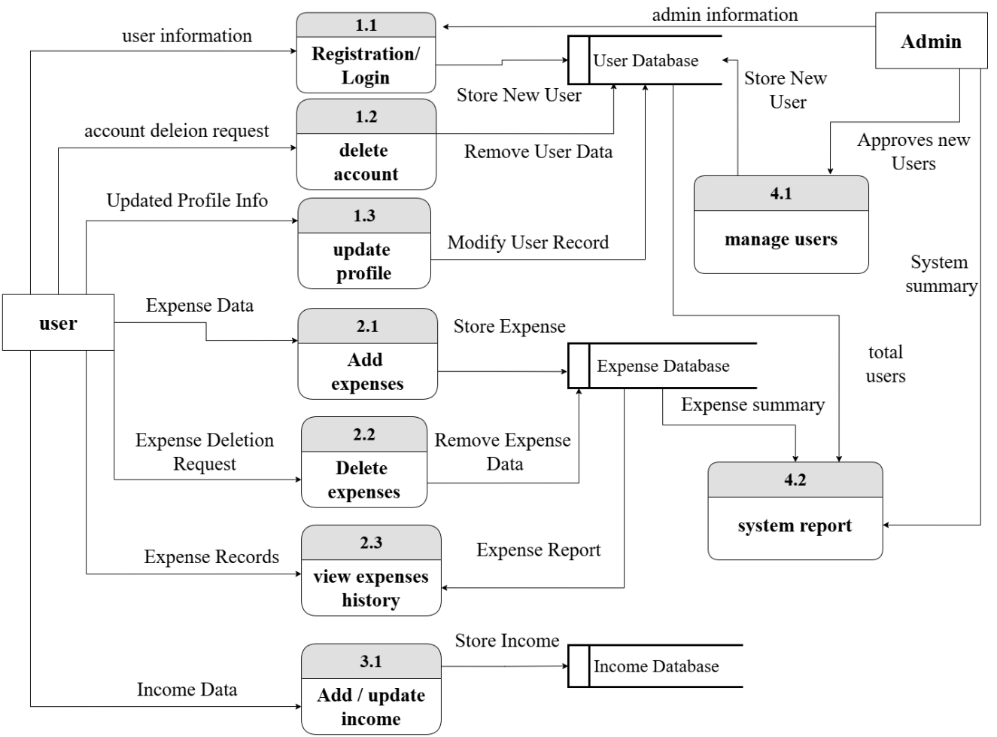

Figure 3.13 Physical DFD of EMS

## CHAPTER 4

## IMPLEMENTATION AND TESTING

### 4.1 Implementation

In first phase, data collected. Data collection took longer time than other phase. It was the critical stage in project’s development. All the physical design of the project turned into working computer code. Many tools and technologies that utilized to develop the system discussed in the preceding chapter.

### 4.2 Tools Used

The various system tools that used in developing both the front-end and back-end of the project discussed in this chapter.

**4.2.1 Front end**

HTML5, CSS3 and JavaScript used for developing the front-end.

**4.2.2 HTML5 (Hypertext Mark-up Language)**

HTML used for structuring webpage design in our project and it provides us with overall skeleton structure of webpage.

**4.2.3 CSS3 (Cascading Style Sheets)**

CSS used to style the HTML document in our project. It used to make our webpages responsive.

**4.2.4 JavaScript (Js)**

JavaScript used to make our webpages interactive and many JavaScript functions such as dialogue box used in this project to make webpages interactive and user friendly.

**4.2.5 Backend**

The backend implemented using PHP, MySQL and XAMPP. MySQL used to design the database.

**4.2.6 PHP**

It used to develop dynamic and interactive webpages.

**4.2.7 MySQL**

It mainly used for the purpose of database.

**4.2.8 XAMPP**

XAMPP used for local server and database to fulfil the need of the project and Apache and MySQL is used as local server and database.

### 4.3 Implementation Details of Modules

The proposed system is composed of different modules, each module handling specific functionalities. Below are the description of these modules.

1. **User Management Module**

* **Register:** Users can create an account by providing details like name, email, and password.
* **Login:** Secure authentication using PHP and MySQL.
* **Update User Profile:** Users can edit personal details and preferences.
* **Delete User Account:** Users can permanently remove their account and data.

1. **Expense Management Module**

* **Add Expenses:** Users can enter expense details, including amount, category, and date.
* **Delete Expense:** Users can remove an expense from their records if needed.

1. **Income Management Module**

* **Add Income:** Users can record income details for better financial tracking.
* **Update Income:** Users can modify income entries if required.

1. **Admin Management Module**

* **Manage Users (Approval):** Admins can verify and approve user registrations.
* **View Platform Insights:** Admins can monitor system activities, including total expenses, user engagement, and financial reports.

### 4.4 Testing

Testing was performed to investigate and validate the behaviour of a fully integrated software product. Before deploying website, it must be thoroughly tested. As a result, this application’s test cases were written. Some of the types of testing that we did are described below.

### 4.4.1Test Cases for Unit Testing

Table 4.1 Test Cases for Registration Module

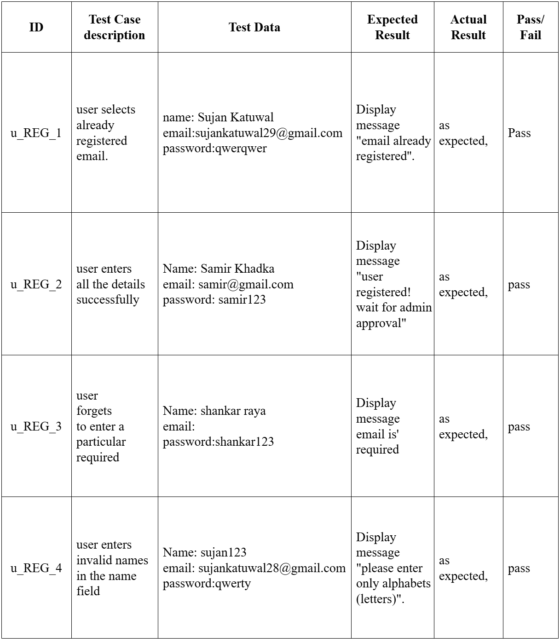

Table 4.2 Test Cases for User Login Module

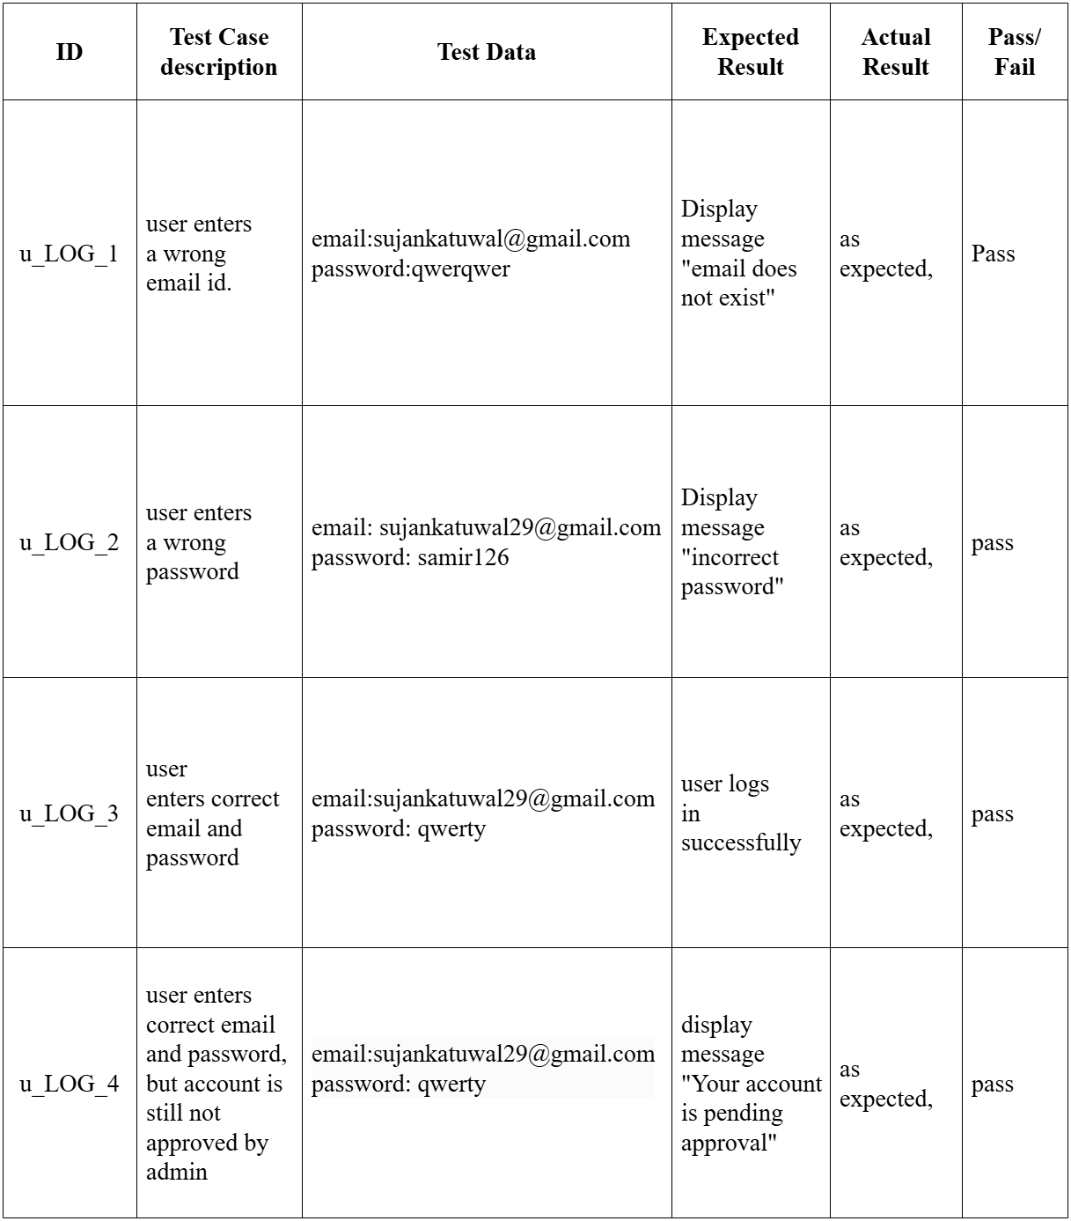

Table 4.3 Test Cases for Add Expenses Module

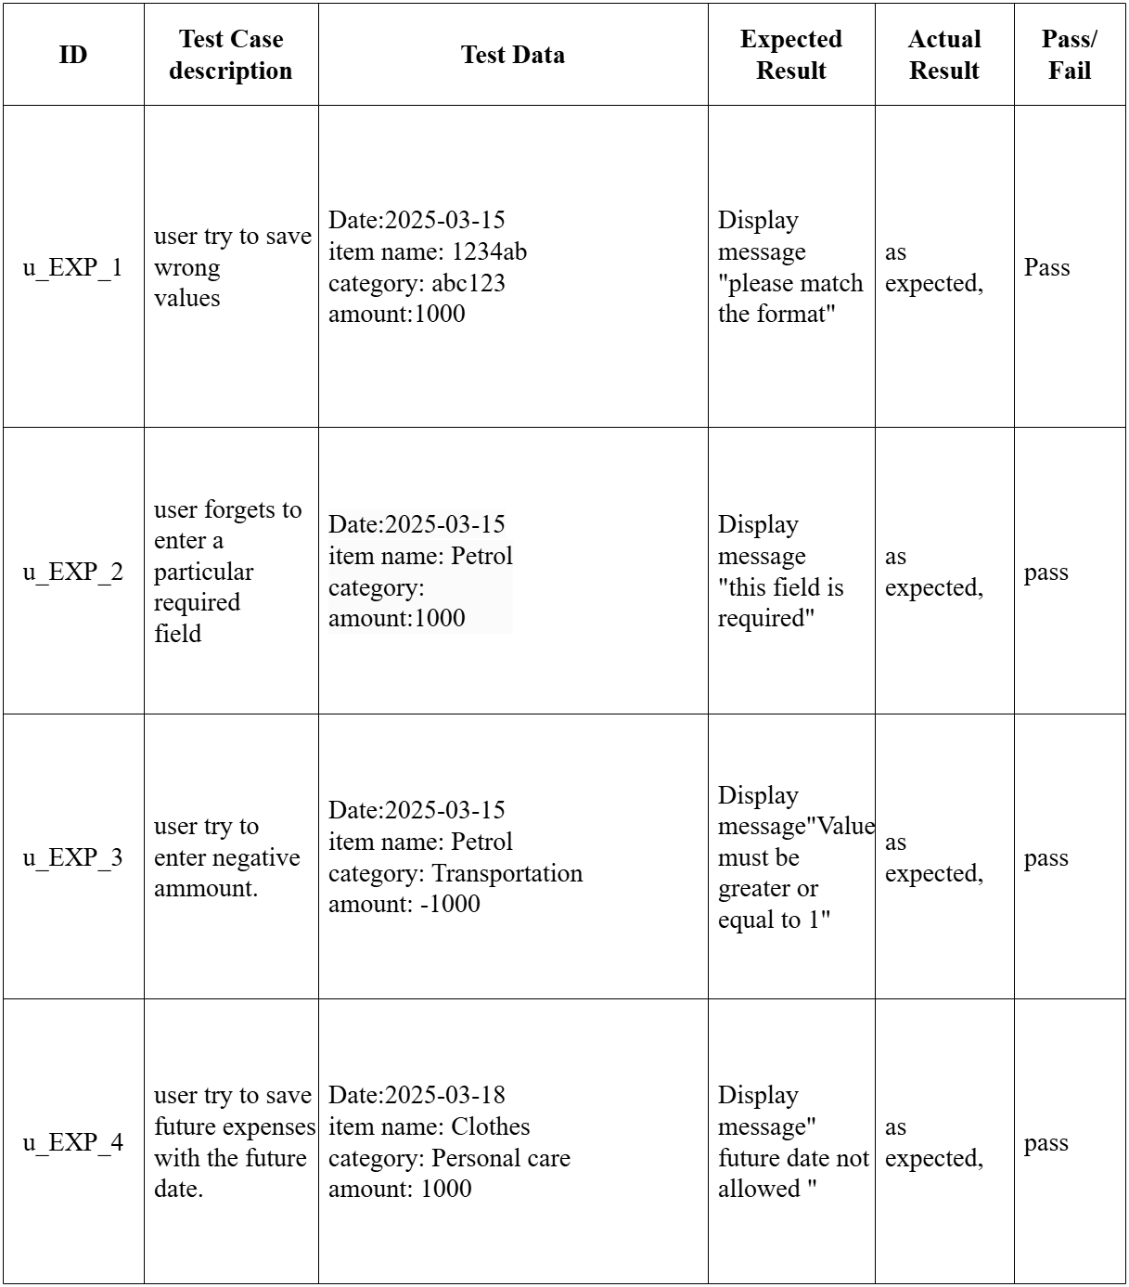

Table 4.4 Test Cases for Add Income Module

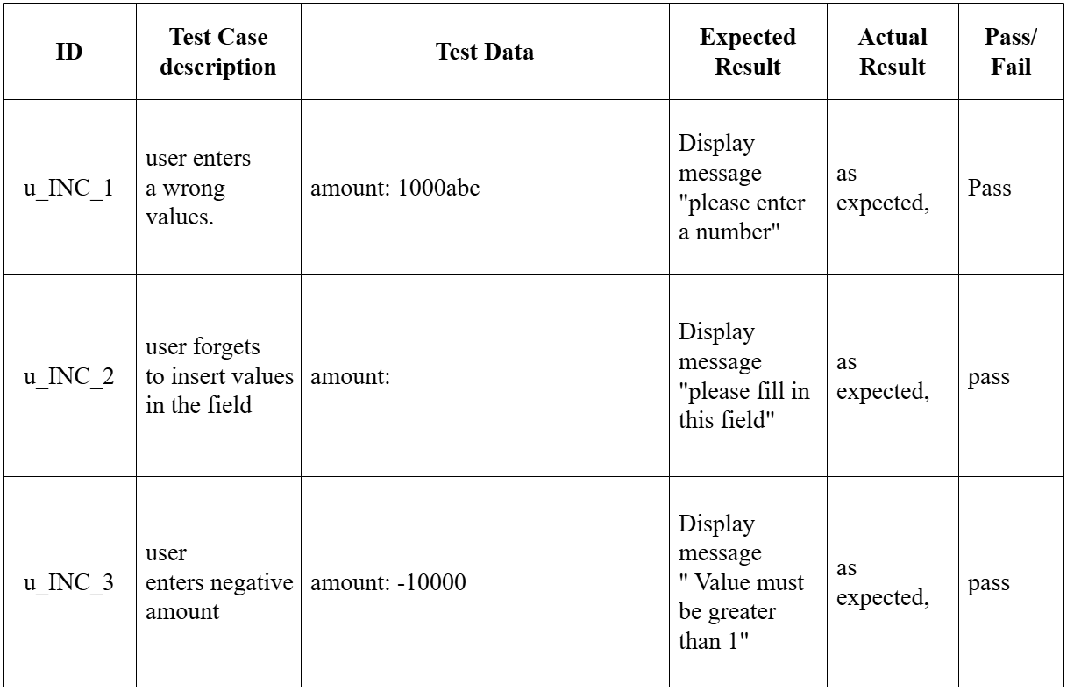

### 4.4.2 Test Case for System Testing

Check system behavior,

* If the site launches properly with all the relevant pages, features and logo.
* If the user can register/login to the site.
* If the content of pages is properly aligned, well managed and without spelling mistakes.
* If session working as expected.
* If a user is satisfied with the site after utilizing it, or if the user does not find it difficult to utilize it.

## CHAPTER 5

## CONCLUSION AND FUTURE RECOMMENDATION

### 5.1 Lesson Learnt / Outcome

With the completion of the project, it was possible to achieve the project’s goal. After filling the registration form, user can view and perform different tasks online through web browser. In this way user can save time and perform expense from the website.

### 5.2 Conclusion

Traditionally, expenses were recorded manually on paper, which was time-consuming, error-prone, and difficult to manage. Retrieving past records, categorizing expenses, and generating reports required significant effort, often leading to inaccuracies and inefficiencies.

The Expense Management System overcomes these challenges by providing a digital, automated solution for tracking, analyzing, and managing expenses. With real-time data entry, automated calculations, it eliminates manual errors and improves financial decision-making. Additionally, its secure, user-friendly interface make expense management more efficient and convenient for individuals and businesses. Overall, this system enhances financial control and simplifies budgeting, offering a modern alternative to traditional expense tracking.

### 5.3 Future Recommendation

There are many things that can be added in the future to improve this website such as user experience, and portability. There is more to be done, thus this system can be seen of as a launching pad for something bigger to come. All of them need more time and resources to complete, but they are still highly realistic and achievable goals.

* Enhance user profiles
* Add forget password
* Download expenses report
* Responsive website
* Filter Expenses

## APPENDICES

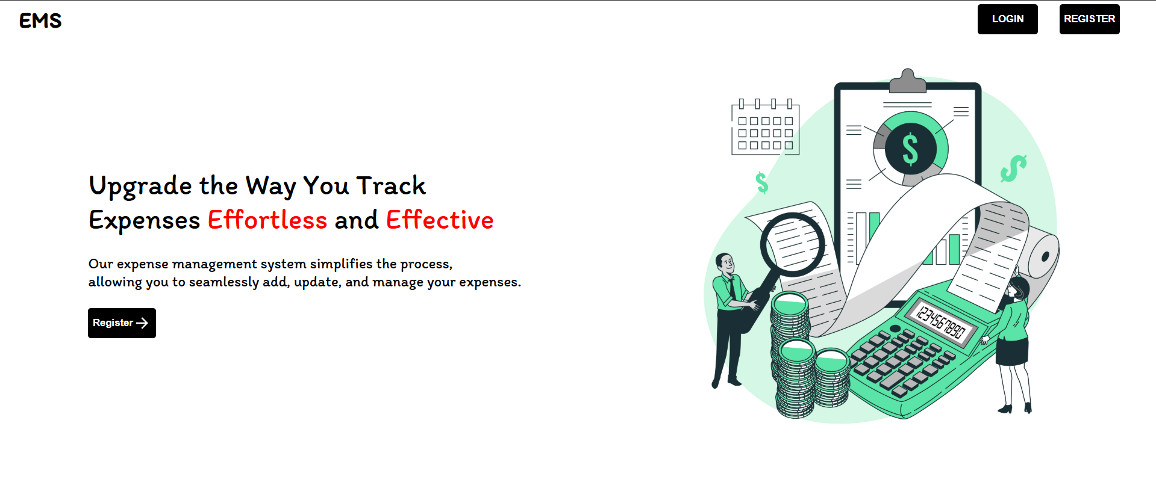

Figure 5.1 Home page

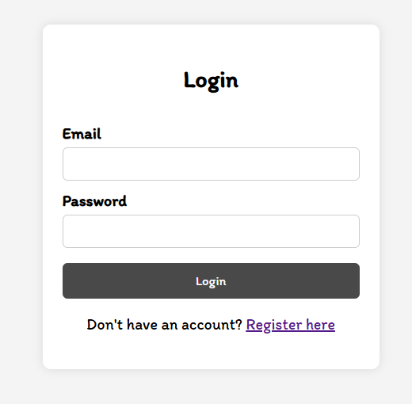

Figure 5.2 login page

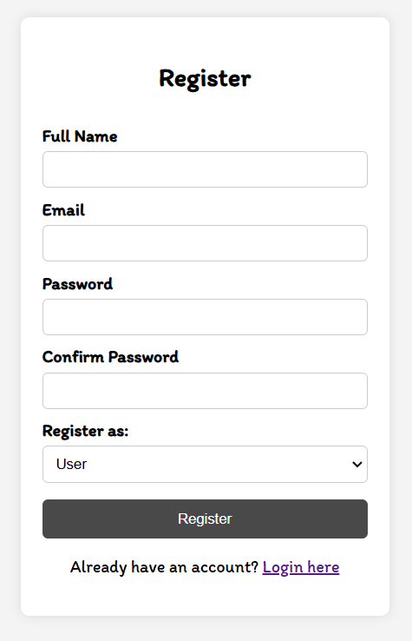

Figure 5.3 Sign Up page

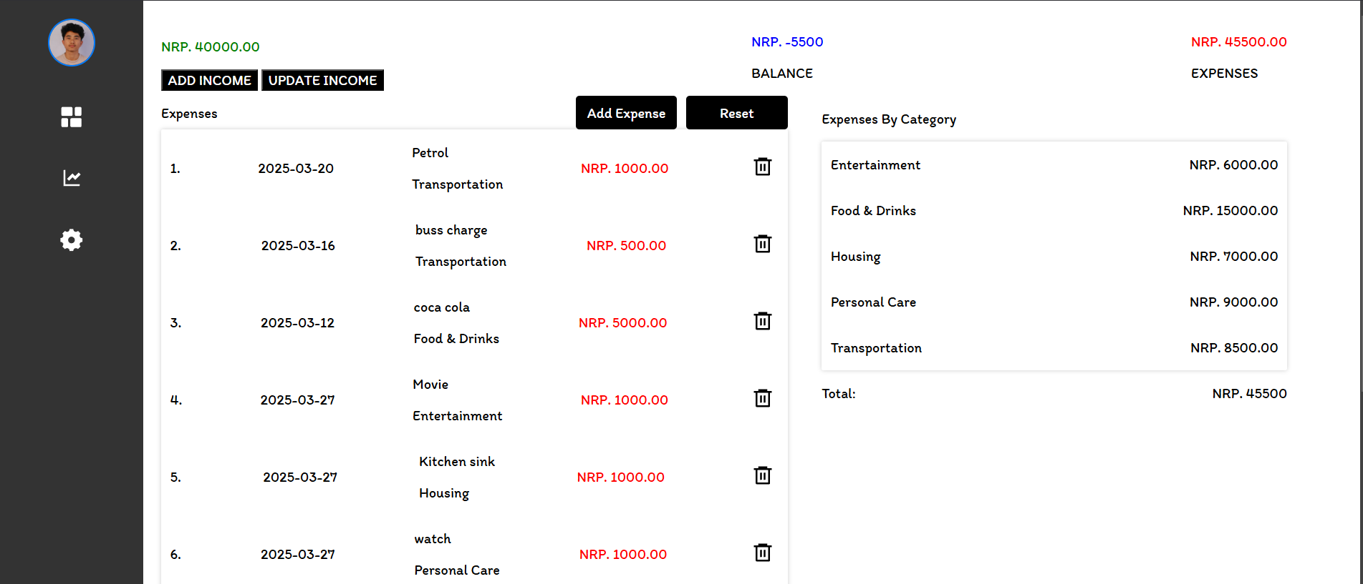

Figure 5.4 Expenses page

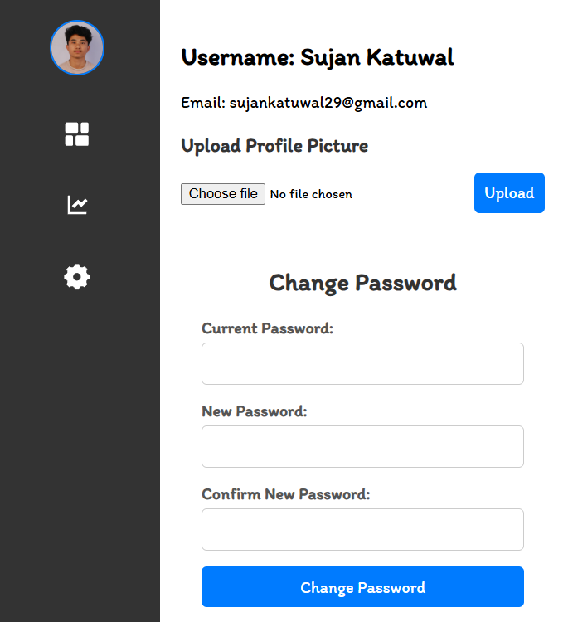

Figure 5.5 User profile page

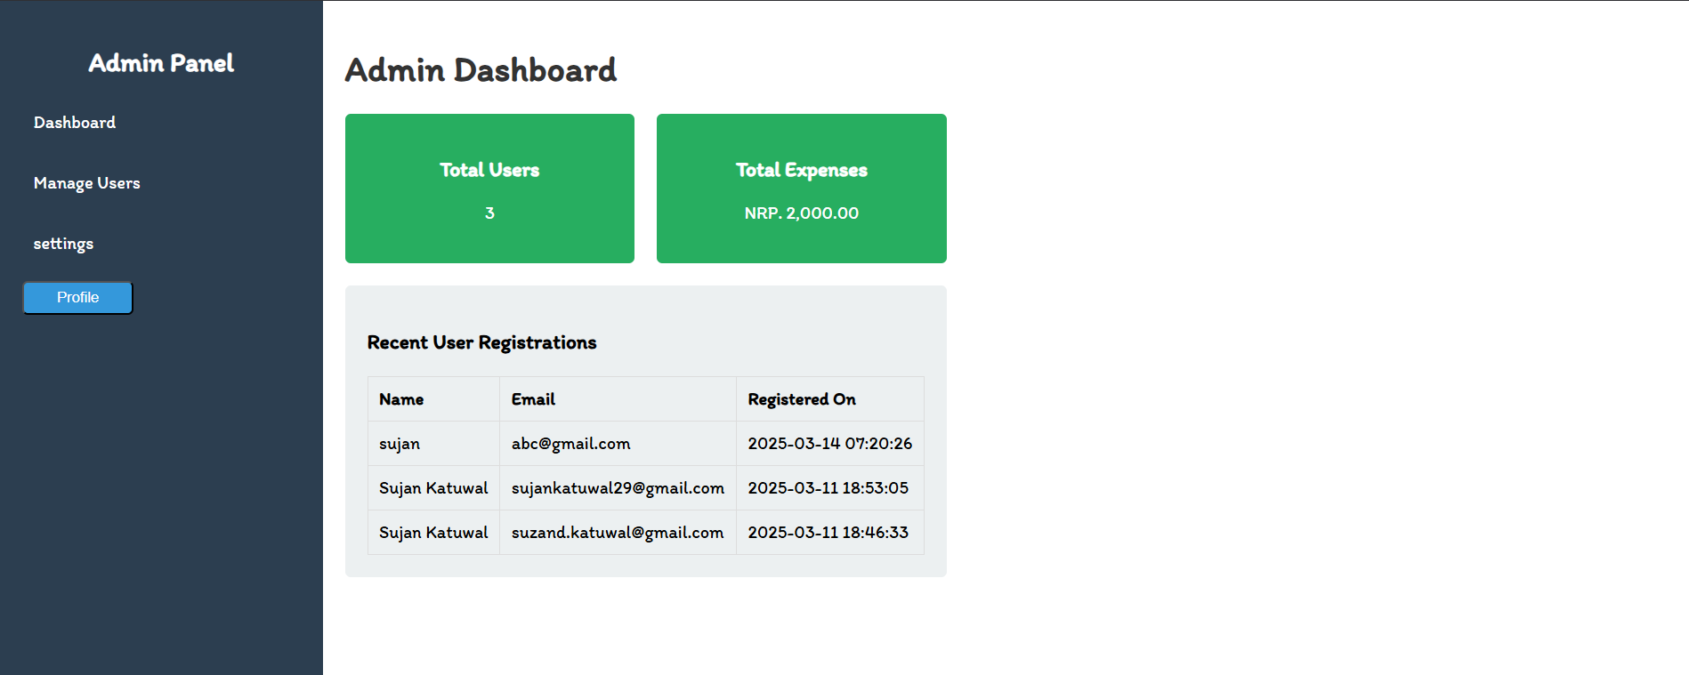

Figure 5.6 Admin Dashboard page

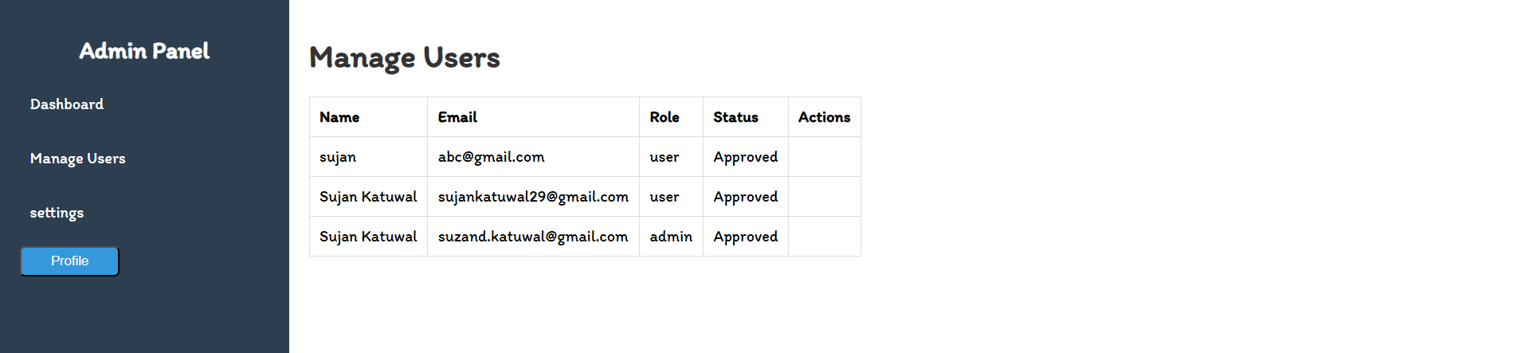

Figure 5.7 Manage users page

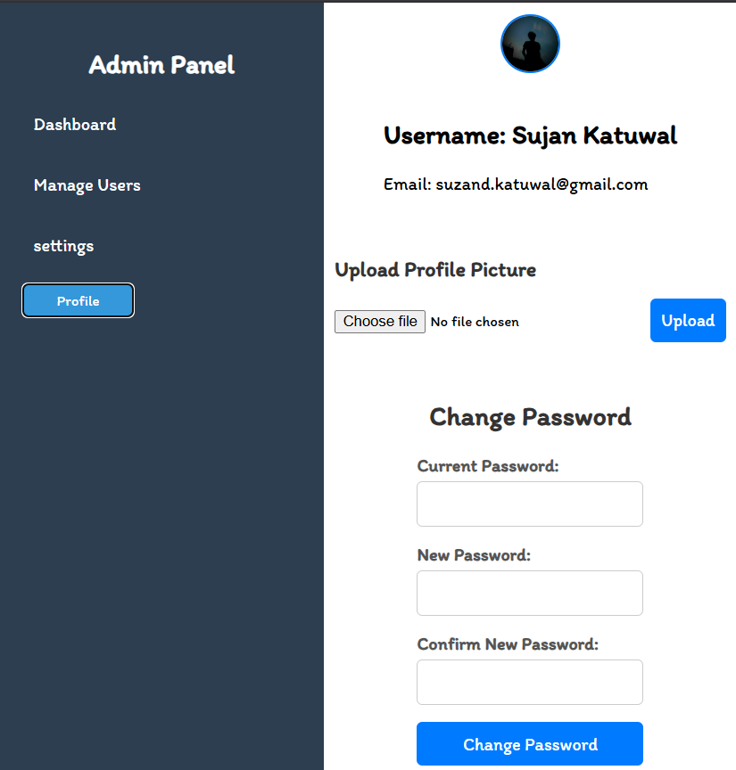

Figure 5.8 Admin profile page

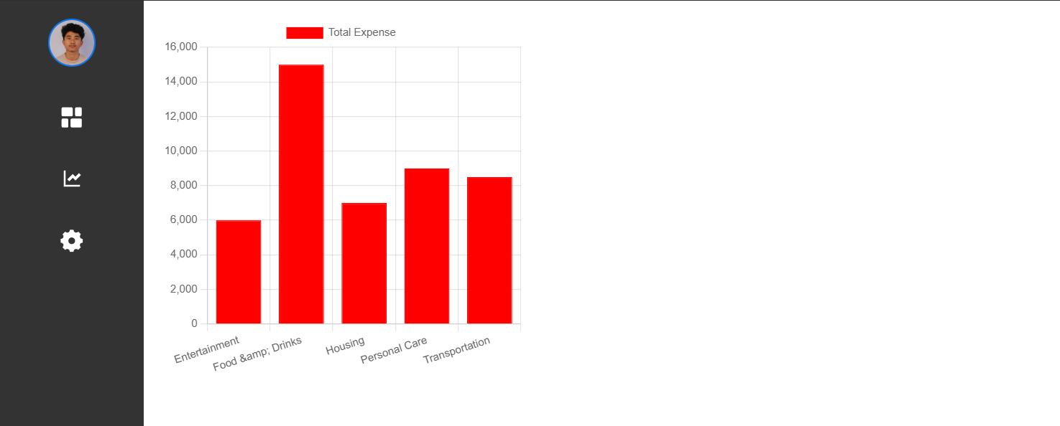

Figure 5.9 Users Charts Page



Figure 5.10 Users Settings Page

## REFERENCES

[1] Smith, J., et al. "Challenges in Traditional Expense Management." Journal of Business Finance, 2020.

[2] Kumar, R., & Sharma, P. "Efficiency Gains from Automated EMS." Financial Systems Review, 2021.

[3] Williams, L., & Thompson, D. "Impact of Expense Management Systems on Operational Efficiency." Business & Economics Journal, 2019.

[4] "Expensify," [Online]. Available: <https://www.expensify.com/>. [Accessed: 02-Mar-2025].

[5] "Zoho Expense," [Online]. Available: https://www.zoho.com/. [Accessed: 02-Mar-2025].

[6] "Emburse," [Online]. Available: <https://www.emburse.com/>. [Accessed: 02-Mar-2025].

[7] "BILL Spend & Expense," [Online]. Available: https://www.bill.com/product/spend-and-expense. [Accessed: 02-Mar-2025].